Description.

Using data available from Business Analysis ArcGIS Maps determine the three locations following the instructions provided below. We will further identify the geocodes of the shortlisted locations using ArcGIS Pro.

Find the best Three Locations in the DFW area for opening a new branch of a restaurant chain that covers best target customer groups that explained in detail on the next page.

Other than that the locations must have accessible within 10 minutes drive for a targeted population that satisfies the minimum requirements as described below.

• Population more than 25,000

• Age range 15-54 years old

• Asian population more than 2,000

• Average income more than $60,000

Target Customers Description.

CUSTOMER PROFILE 1: *This is the new growth market, with a profile similar to the original: young professionals with families that have opted to trade up to the newest housing in the suburbs. This is an affluent market but with a higher proportion of mortgages. Residents are well-educated professionals with a running start on prosperity.*

CUSTOMER PROFILE 2: *Residents are predominantly single, well-educated professionals in business, finance, legal, computer, and entertainment occupations. They are affluent and partial to city living—and its amenities. Neighborhoods are densely populated, primarily located in the cities of large metropolitan areas. Although single householders technically outnumber couples, this market includes a higher proportion of partner households, including the highest proportion of same-sex couples. Residents are more interested in the stock market than the housing market. They are active and health conscious, and care about the environment.*

CUSTOMER PROFILE 3: *Armed with the motto “you’re only young once,” these residents live life to its full potential. These educated young singles aren’t ready to settle down; they tend to not own homes or vehicles and choose to spend their disposable income on upscale city living and entertainment. Dressed head to toe in the most current fashions, their weeknights and weekends are filled discovering local art and culture, dining out, or exploring new hobbies. Their vacations are often spontaneous, packed with new experiences and chronicled on their Facebook pages.*

CUSTOMER PROFILE 4: *Residents are younger and more mobile and ethnically diverse than the previous generation. They are ambitious, working hard to get ahead, and willing to take some risks to achieve their goals. The recession has impacted their financial well-being, but they are optimistic. Their homes are new; their families are young. And this is one of the fastest-growing markets in the country.*

CUSTOMER PROFILE 5: *Gen Y comes of age: Well-educated young workers, some of whom are still completing their education, are employed in professional/technical occupations, as well as sales and office/administrative support roles. These residents are not established yet, but striving to get ahead and improve themselves. This market ranks in the top 5 for renters, movers, college enrollment, and labor force participation rate. Almost 1 in 5 residents move each year. More than half of all householders are under the age of 35, the majority living alone or in shared nonfamily dwellings. Median household income is still below the US Smartphones are a way of life, and they use the Internet extensively. Consumers are diverse, favoring densely populated neighborhoods in large metropolitan areas; over 50% are located in the South (almost a fifth in Texas), with the rest chiefly in the West.*

Creat a map-based required conditions in zip code level as shown in the following image.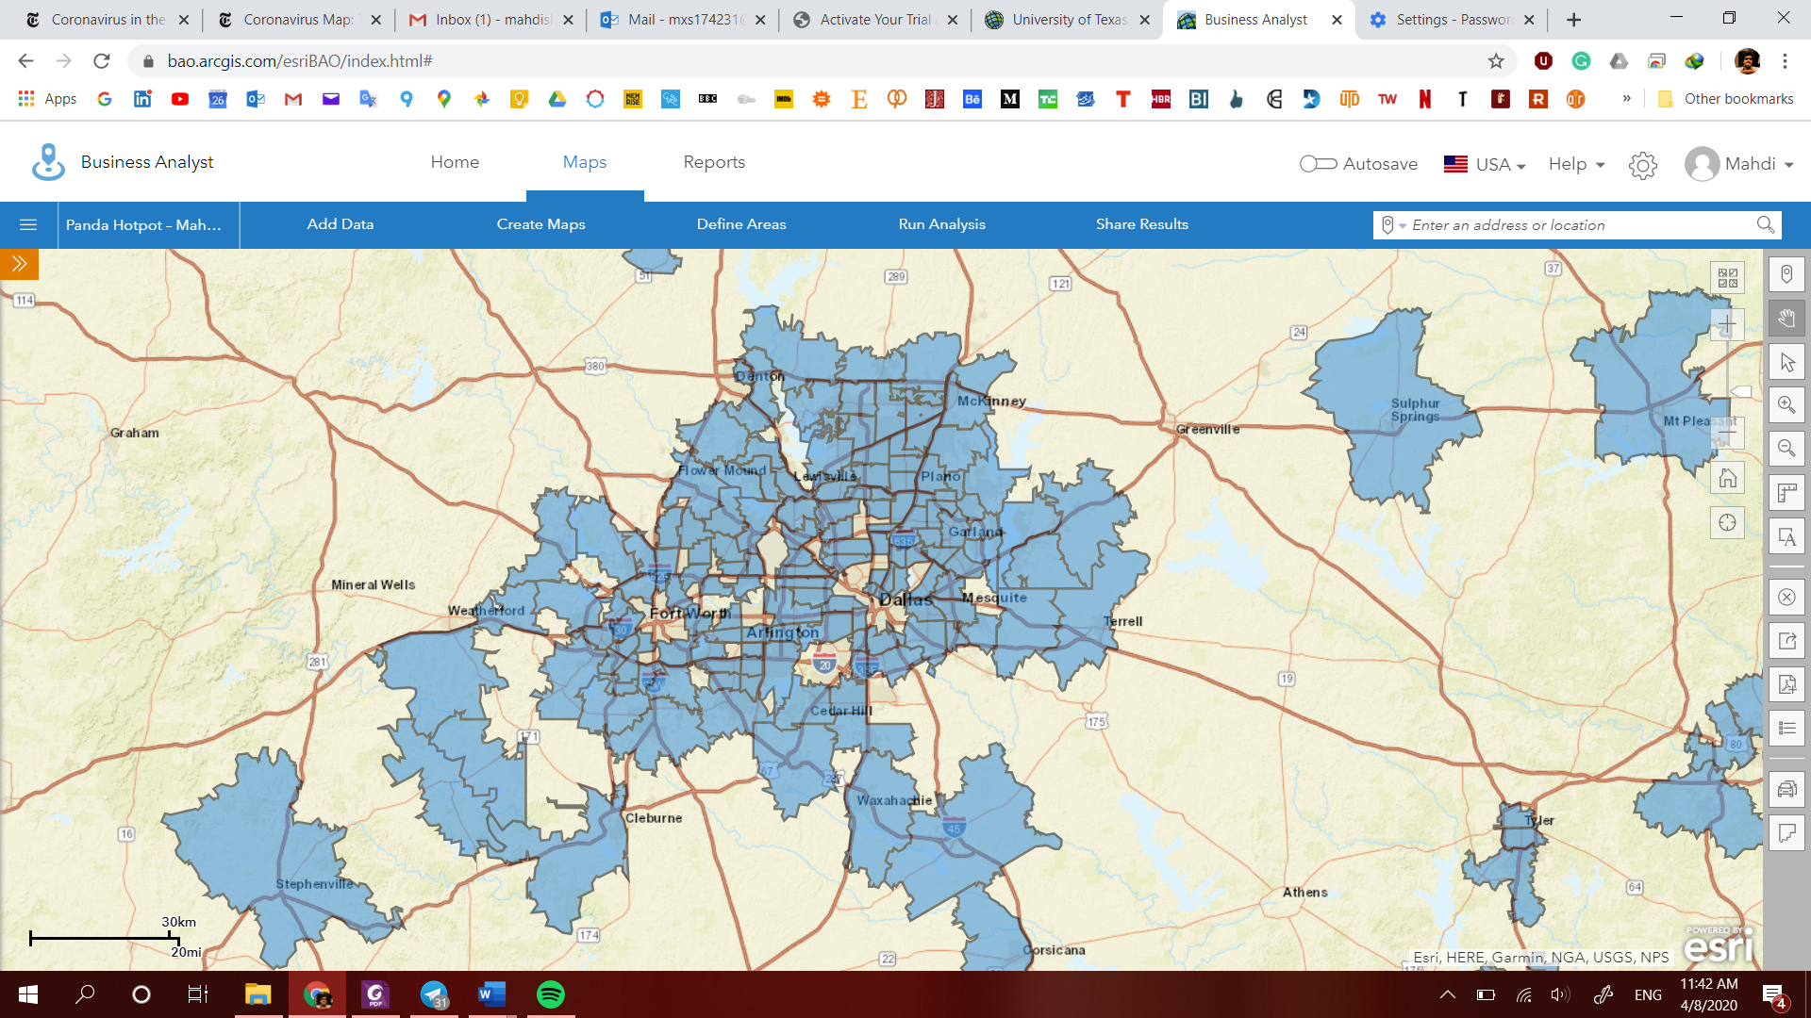

After applying the required filters as shown on the left side of the image.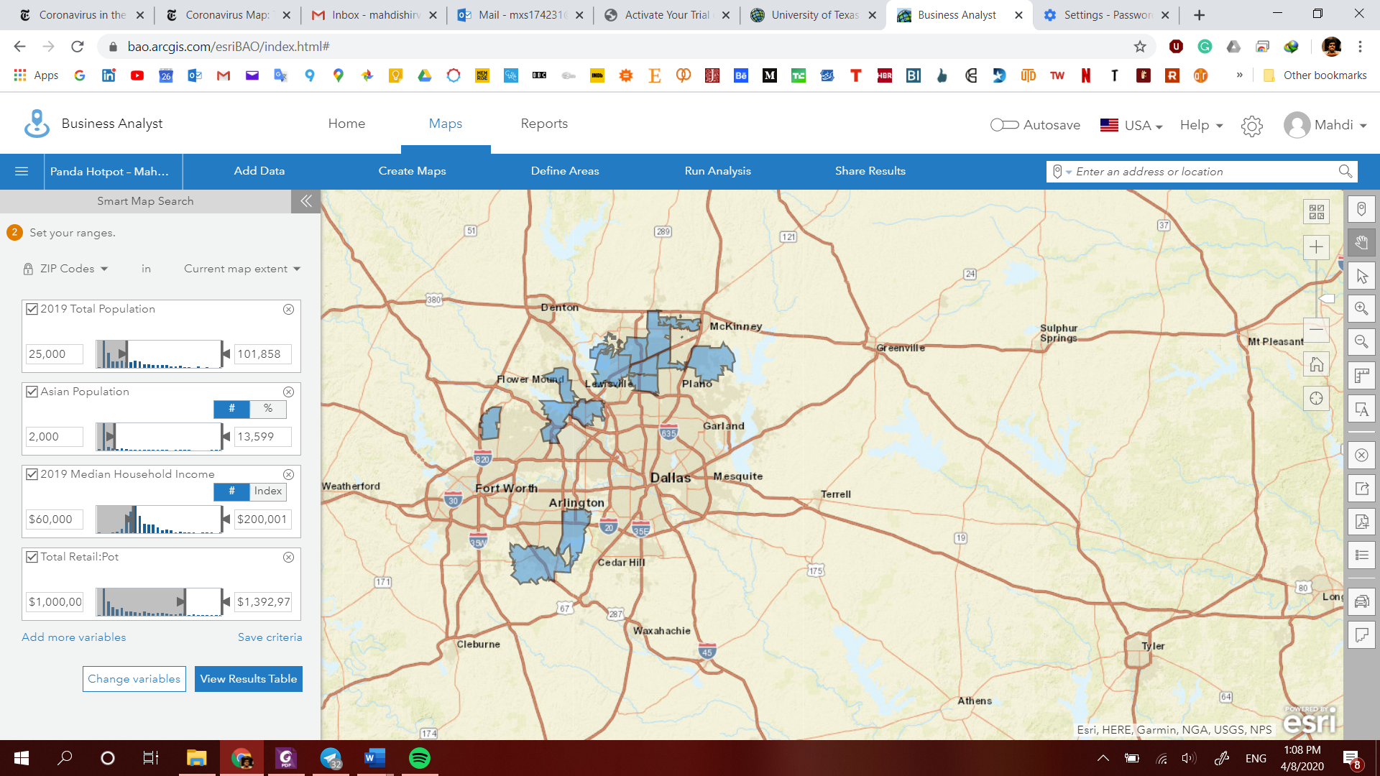

After matching the suggested profiles with the Esri default categories.

* Customer Profile 1: 2019 Boomburbs (1C) Tapestry Adult Population (Esri)
* Customer Profile 2: 2019 Laptops and Lattes (3A) Tapestry Adult Population (Esri)
* Customer Profile 3: 2019 Trendsetters (3C) Tapestry Adult Population (Esri)
* Customer Profile 4: 2019 Up and Coming Families (7A) Tapestry Adult Population (Esri)
* Customer Profile 5: 2019 Young and Restless (11B) Tapestry Adult Population (Esri)

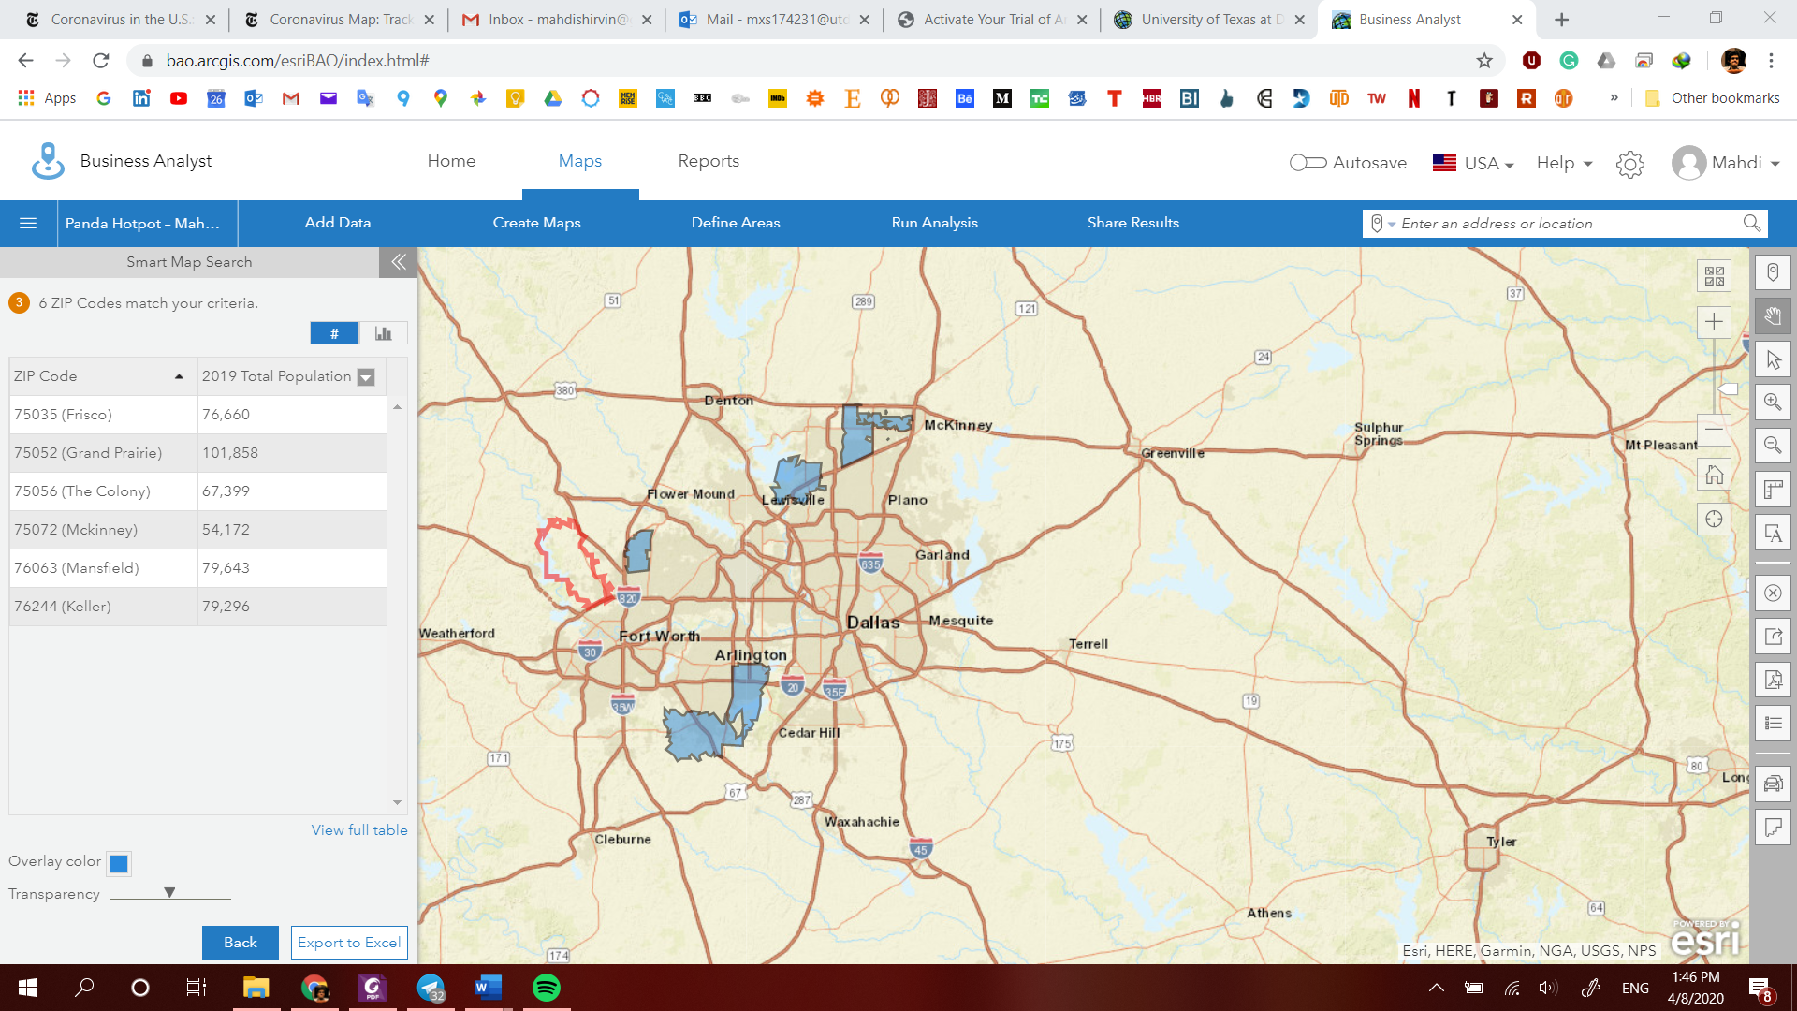

Choosing the top three locations based on the population and finding the locations with 5,10, and 15 minutes driving distance to the center of each of the zip codes.

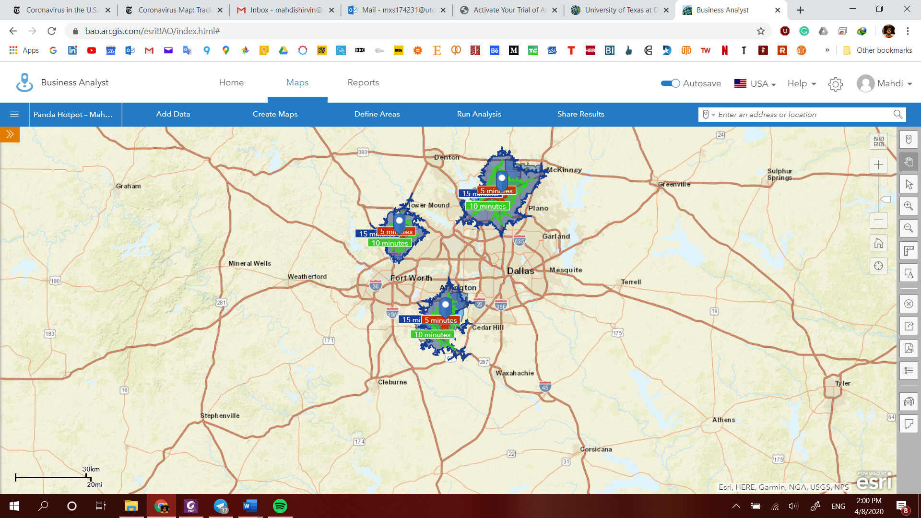

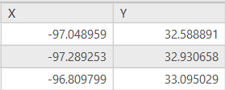

|  |
| --- |
| Loc 1 |
| Loc 2 |
| Loc 3 |

**The suggested locations in the nearest available slot to open a restaurant with all the details in ArcGIS PRO.**

